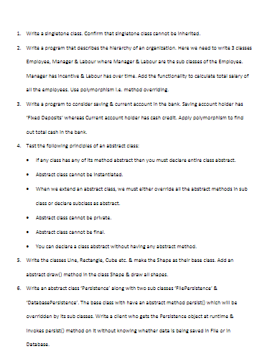

**1.**

**package** oopsConcept;

**public** **class** SingleTon {

**private** **static** SingleTon *singleton*;

**private** SingleTon()

{

System.***out***.println("it invoke to create only one object");

}

**public** **static** SingleTon getInstance() {

**if** (*singleton* == **null**) {

*singleton* = **new** SingleTon();

}

**return** *singleton*;

}

}

**class** Test{

**public** **static** **void** main(String[] args) {

SingleTon sinlge =SingleTon.*getInstance*();

}

}

**2.**

**package** oopsConcept;

**public** **class** Employe {

**int** employeeId;

String employeeName;

**double** salary;

**public** Employe(**int** employeeId, String employeeName, **double** salary) {

**super**();

**this**.employeeId = employeeId;

**this**.employeeName = employeeName;

**this**.salary = salary;

}

**public** **int** getEmployeeId() {

**return** employeeId;

}

**public** **void** setEmployeeId(**int** employeeId) {

**this**.employeeId = employeeId;

}

**public** String getEmployeeName() {

**return** employeeName;

}

**public** **void** setEmployeeName(String employeeName) {

**this**.employeeName = employeeName;

}

**public** **double** getSalary() {

**return** salary;

}

**public** **void** setSalary(**double** salary) {

**this**.salary = salary;

}

}

**class** Manager **extends** Employe{

**public** Manager(**int** employeeId, String employeeName, **double** salary) {

**super**(employeeId, employeeName, salary);

}

**public** **double** getSalary() {

**return** salary;

}

}

**class** Labour **extends** Employe{

**public** Labour(**int** employeeId, String employeeName, **double** salary) {

**super**(employeeId, employeeName, salary);

}

**public** **double** getSalary() {

**return** salary;

}

}

**class** MethodOverridingMain {

**public** **static** **void** main(String[] args) {

Labour d1=**new** Labour(1,"Arpit" ,20000);

Labour d2=**new** Labour(2,"John" ,15000);

Manager m1=**new** Manager(1,"Amit" ,30000);

Manager m2=**new** Manager(2,"Ashwin" ,50000);

System.***out***.println("Name of Employee:" +d1.getEmployeeName()+"---"+"Salary:"+d1.getSalary());

System.***out***.println("Name of Employee:" +d2.getEmployeeName()+"---"+"Salary:"+d2.getSalary());

System.***out***.println("Name of Employee:" +m1.getEmployeeName()+"---"+"Salary:"+m1.getSalary());

System.***out***.println("Name of Employee:" +m2.getEmployeeName()+"---"+"Salary:"+m2.getSalary());

}

}

**5.**

//creating a Shape abstract class

**abstract** **class** Shape {

**abstract** **void** draw();

}

//Drawing line shape

**class** line **extends** Shape{

**void** draw() {

System.***out***.println("drawing line...");

}

}

//Drawing cube shape

**class** cube **extends** Shape{

**void** draw()

{

System.***out***.println("drawing cube...");

}

}

//Drawing rectangle shape

**class** rectangle **extends** Shape{

**void** draw()

{

System.***out***.println("drawing rectangle...");

}

}

//calling main method

**class** hello{

**public** **static** **void** main(String args[])

{

Shape a= **new** line();

a.draw();

Shape b= **new** rectangle();

b.draw();

}

}

**Output:**

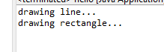

**6.**

**package** file;

**abstract** **class** persistance{

**public** **abstract** **void** persist();

}

**class** filePersistance **extends** persistance {

@Override

**public** **void** persist() {

System.***out***.println("data is being saved in in file");

}

}

**class** databasePersistance **extends** persistance {

@Override

**public** **void** persist() {

System.***out***.println("data is not being saved in in databse");

}

}

**public** **class** Persistence{

**public** **static** **void** main(String[] args) {

filePersistance p =**new** filePersistance();

p.persist();

databasePersistance p1=**new** databasePersistance();

p1.persist();

}

}

**Output:**

**o6.PNG**